BIODEGRADABILITY AND COMPOSTING OF PACKAGING MADE FROM INVASIVE PLANT BASED MATERIALS

Mija Sežun, Igor Karlovits, Daša Medvešček, Urška Kavčič

Pulp and Paper Institute Ljubljana, Slovenia

Professional paper

doi:

email@email.com

**Abstract:** Packaging has many useful properties throughout its life cycle. It is used to protect against injuries, contamination and tempering. However, we know that each packaging after its use becomes waste. There are many pathways that we are meeting at the end packaging life cycle. Some have minor and some major environmental impacts. The main impact is how the packaging will be disposed, other environmental impacts depend on the choice of material, eco design and local waste management facilities. In practice we know different ways to remove packaging: reuse, recycle, compost, incineration and landfilling. However, we must be aware that the disposal is unacceptable, the landfills are closing and the negative environmental impacts are high. Composting and recycling have their own requirements, packaging must be biodegradable and must not contain interfering substances. Requirements are determined within the environmental registration and must be taken into account during implementation. In our study, we will present the benefits of using alternative sources and show environmental acceptability. Environmental acceptability will be determined on the basis of compost and recycling test. The study will include paper from the Solidago species, Acacia and Fallopia japanese plants. These plants have good characteristics for paper and cardboard production. In the future, the presence of alternative varieties of lignocellulosic biomass will be a major contribution for paper and packaging industry.

**Keywords:** biodegradability, compostability, lignocellulosic material, packaging

1 Introduction

Lignocellulose biomass includes wood biomass, annual plants, green residuals, exotic invasive plant species and biomass waste from agriculture and industry, represent a rich source of raw material for various products, including paper products (packaging). Lignocellulosic biomass contains lignin and cellulose, which are very useful components. They offer many advantages in the design and engineering of polymer composites, because of their renewability, low abrasiveness, load bearing capacity, and biodegradable nature (Faruk et al., 2012). That kind of products are cost competitive and can be applicable in various sectors, including durable and biodegradable products. Lignocellulosic composites are defined as polymer composites in which lignocellulosic materials are major fillers. They are classified into two types based on their biodegradability in soil and composting facilities as shown in Figure 1 (as represented on left-hand side):

1. Non-biodegradable lignocellulosic composites:Lignocellulosic composites belonging to this categorycan be made up of both petro and/or renewablepolymers, but they are not biodegradable ineither soil or composting facilities. For example:polypropylene-natural fiber composites, biobasednylon-natural fibers composites, etc.

2. Biodegradable lignocellulosic composites:Lignocellulosic composites belonging to thiscategory can be made up of both petro and/ or renewable polymers. They are biodegradable in either soil or composting facilities. Forexample: poly (lactic acid)-natural fiber composites,poly (butylenadipate-co-terephthalate) -natural fiber composites, etc. It is well knownthat PLA is a renewable resource-based polymer,while PBAT is a petro-based polymer (Muniyasamy et al., 2013).

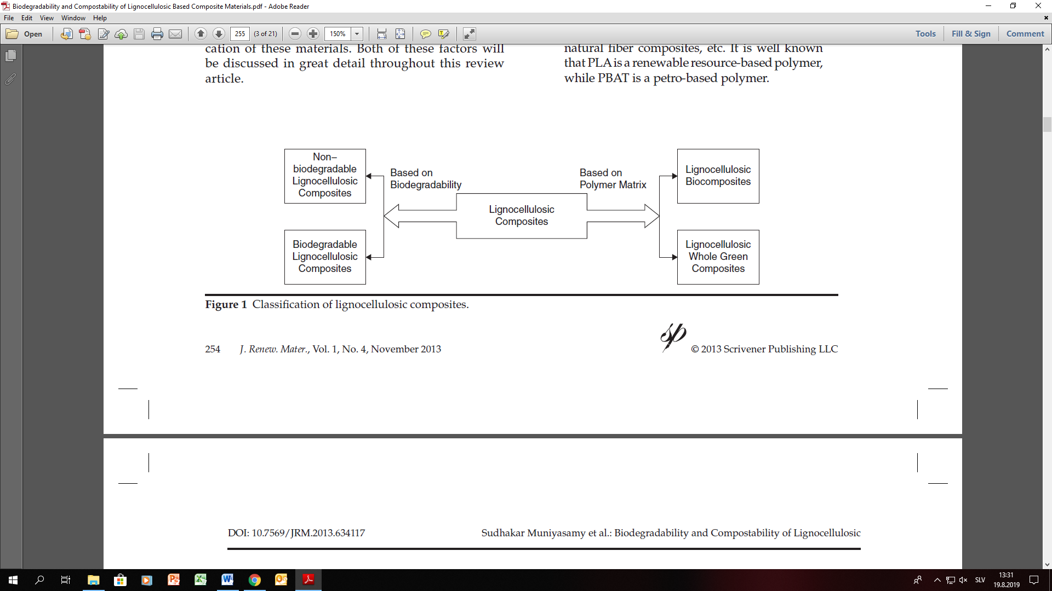

Figure 1: Classification of lignocellulosic composites (Muniyasamy et al., 2013)

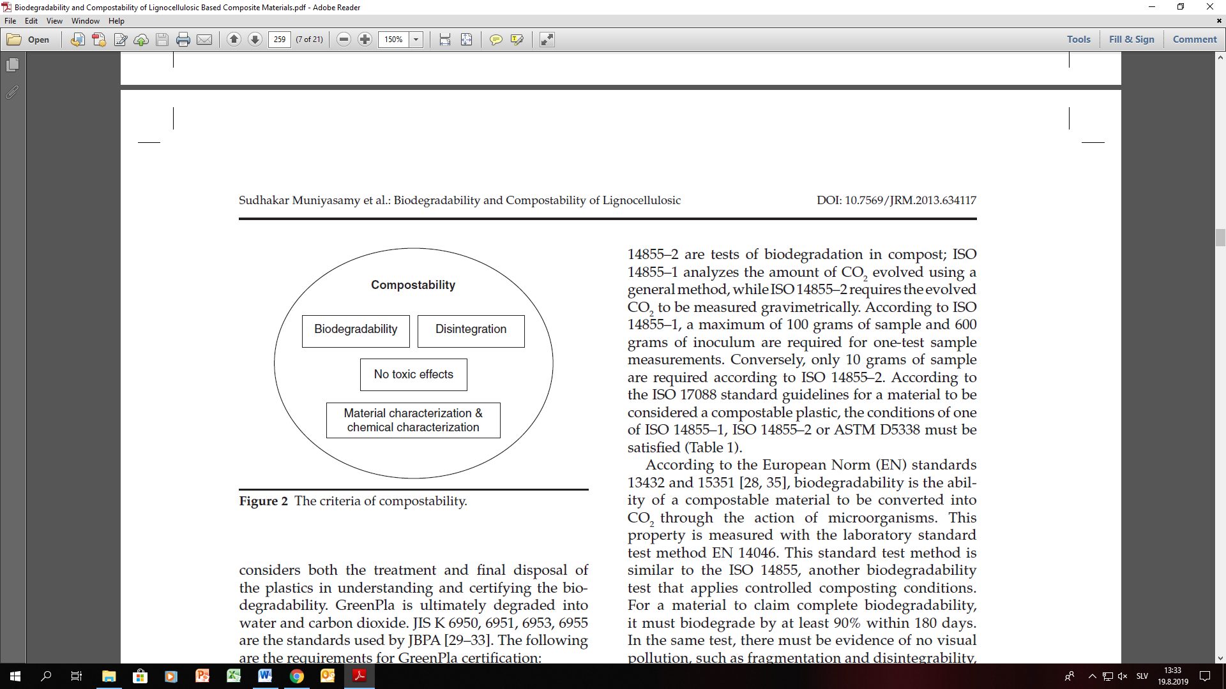

Figure 2: The criteria of compostability (Muniyasamy et al., 2013)

There have been many analyses carried out on plastic materials, but the focus on paper and cardboard packaging is increasing, because of well-known fact about its biodegradability. Biodegradability and compostability testing are covered by international standards such as: CEN (European Committee for Standardization), ASTM (American Society for Testing and Materials), ISO (International Standards Organization) and the Japan BioPlastics Association. Some of the most widely adopted standards for biodegradation of polymers are EN 13432, ASTM D6400, ISO/DIS 17088 and JISK 6953.

According to the European Directive on packaging and packaging waste (EN 13432), the packaging waste processed through composting must be biodegradable in nature and it should not hinder any unrecoverable materials. Lignocellulosic materials produced from various agro-industrials, agro-food waste and agro-forestry feedstocks have been widely used in the development of polymer composites. These renewable resource based materials can have a reduced environmental impact in comparison to non-renewable resource based plastic materials. The assessment of total biodegradability of that kind of bio composites can expose the final environmental fate of their individual components during composting (Way et al., 2012). Composting is a process in the waste hierarchy and has an important role in reducing the volume of biodegradable biowaste. Composting is a biological process which converts heterogeneous organic wastes into humus like substances by mixed microbial population under controlled optimum conditions of moisture, temperature and aeration. In composting, microorganisms convert organic materials into product like soil humus. Through composting organic waste materials are decomposed and stabilized into a product that can be used as soil conditioner and/or organic fertilizer. The composting process requires different microorganisms such as bacteria, actinomycetes and fungi that are widespread in nature (Atalia et al., 2015). The ability of fungi to degrade lignocellulosic materials is due to their highly efficient enzymatic system. Fungi have two types of extracellular enzymatic systems; the hydrolytic system, which produces hydrolases that are responsible for polysaccharide degradation and a unique oxidative and extracellular ligninolytic system, which degrades lignin and opens phenyl rings. Lignocellulosic residues from wood, grass, agricultural, forestry wastes and municipal solid wastes are particularly abundant in nature and have a potential for bioconversion (Sanchez, 2009).Hatakka and Hammel (2010) report that many fungi degrade cellulose and hemicelluloses using extracellular hydrolytic enzymes, but fungi that degrade woody biomass are the only ones to efficiently degrade polysaccharides encased in lignin. White-rot basidiomycetes begin by mineralizing the lignin, using extracellular oxidative enzymes to cleave this recalcitrant biopolymer.Pulp and paper packaging treatment under aerobic and anaerobic composting conditions in digesters are already in the development and use phase, accepted in all developed countries (Heerenklage et al., 2000).

2 Material and methods

2. 1 Sample

As a sample we used packaging made from paper from invasive plants (Solidago species, Acacia and Fallopia Japanese plant). The paper was produced at the Pulp and Paper Institute.

To test the environmental life cycle end use of invasive plant-based paper packaging (side stream without deinking and recycling), we have made packaging prototypes (Figure 3). The prototypes were designed, printed with UV-LED printer Apex in 4 colours (CMYK) using Nazdar 720 UV-LED inks using 15% ink coverage. As base material for the packaging we have used 240 g/m2 paper/boards made from 3 invasive plants: Solidago species, Acacia and Fallopia Japanese plant. The plants were harvested in the Ljubljana municipality as invasive weeds and was recirculated in the form of paper and board. The production of the papers was done at the Pulp and Paper Institute in Ljubljana.

The basic material characteristics of the invasive plants are presented in Table 1. The content of cellulose, hemicellulose and lignin was also determined at the Pulp and Paper Institute.

Table 1. Basic material characteristics of the used invasive plants for packaging

|  |  |  |  |
| --- | --- | --- | --- |
| **Chemical structure** | **Canadian Goldenrod** | **Acacia** | **Japanese knotweed** |
| Cellulose (%) | 27 | 41 | 35 |
| Hemicellulose (%) | 30 | 35 | 37 |
| Lignin (%) | 23 | 22 | 27 |

|  |  |
| --- | --- |
| C:\Users\ICP\Documents\konference-dogodki material\KROŽNA EMBALAŽA konferenca\IMG_2265.jpg | C:\Users\ICP\Downloads\20180530_092920.jpg |

Figure 3: Sample - packaging made of paper from invasive plants

2. 2 Biodegradability test

This guidance defines the determination of the aerobic biodegradability of samples for biological treatment. The anaerobic biodegradability tester is useful for all types of solid specimens that are assumed to be biodegradable. Determination of anaerobic biodegradability is a necessary for further compostability test procedures. The condition for continuing to the compostability test are that the anaerobic biodegradability is at least 90%. If we do not reach this value with a pilot test we cannot proceed and it is considered that the sample is not biodegradable.

To perform the anaerobic biodegradability test one has to know what are the requirements for determining the compostability of the sample. The requirements are covered by the following standards: Prevention by reduction at source SIST EN 13428: 2004, Heavy metals CR 13695-1, Dangerous substances SIST EN 13428: 2004, Reuse of SIST EN 13429: 2004

Biodegradation /Composting SIST EN 13432: 2001. Biodegradation was tested in a respirometer manufactured by ECHO Respirometer ER6 according to ISO 14855 standard. Preparation of samples and compost was carried out in accordance with ISO 14855-1: 2007 / AC: 2010. The air flow was set to 0.2 l / min, the reactor measurement time to 20 minutes (120 minutes in total), the break time to 240 minutes. The compost was obtained through a microbial aerobic process to stabilize the organic matter and the green section. The compost consisted of biodegradable waste (20%), biodegradable waste (40%) and wood (40%). One reactor was only with compost and served as a reference for us. The sample to compost ratio in the reactors was the mass of dry matter in the sample: the mass of dry matter in the compost = 1: 6. The moisture in the reactors was 50%.

CO2 production was evaluated. The production of CO2 in the sample reactors was subtracted by the production of CO2 in the reference reactor.

Figure 4: CO2 production during biodegradation

2.3 Compostability test

Compost was added in to 5 L containers, compost was mixed with previously prepared samples and after that the containers were covered with lids (aerobic conditions). Moisture and biodegradation were monitored every two days, until the end of the test. The compost was obtained from a local composting plant. The composting was carried out at 58 ± 2 ° C, estimated time = 12 weeks. After 8 weeks, the material was sieved over a 2mm diameter sieve. The all samples were compostable, because more than 90% of the material (compost) passed through the sieve.

|  |  |  |
| --- | --- | --- |
| C:\Users\TOSHIBA L50\Downloads\IMG_2284.jpg | C:\Users\TOSHIBA L50\Downloads\IMG_2291.jpg | C:\Users\TOSHIBA L50\Downloads\IMG_2288.jpg |

Figure 5: Preparation of compostability test

3 Conclusion

During our research it was found that the packaging of invasive plants is very environmentally friendly, because it does not contain any substances that could affect the process of biodegradation and composting.

Based on the different characteristics of the samples, regarding the content of cellulose, hemicellulose and lignin (Table 1), it can be expected that the biodegradation will also occur differently. Considering that the *Solidago species* has a much lower content of cellulose, it can be said that the biodegradability was lower than biodegradability of *Acacia* and *Fallopia Japanese plant*.

In addition, it was easily degradable, since the time to run the biodegradability and composting test was below average time for similar products. In the future, it would be wise to consider replacing currently existing raw materials, which are characterized as non-biodegradable, with lignocellulosic raw material or plants, such as invasive ones, which are already a major environmental burden.

**Acknowledgments:** We would like to thank Silvester Bolka from Faculty of Polymer Technology with the help of biodegradability test and to Javno podjetje Vodovod Kanalizacija Snaga for composting material.

4 References

Atalia A., Buha D.M., Bhavsar K.A., Shah, N.K. Review on Composting of Municipal Solid Waste. J. of Env. Sci. 2015, 9, 5, 20-29.

EN 13432: Packaging – Requirements for packaging recoverable through composting and biodegradation-test scheme and evaluation of the fincal acceptance of packaging, European Standard.

Faruk O., Bledzki A.K., Fink H.P., Sain M. (2012) Biocomposites reinforced with natural fibres: 2000–2010. Prog. Polym. Sci. 2012, 37, p. 1552.

Hatakka, A. ,Hammel, K.E. (2010) Fungal Biodegradation of Lignocelluloses. Ind. Appl., 2010, pp. 319-340.

[Heerenklage](https://www.researchgate.net/profile/Joern_Heerenklage2?_sg%5B0%5D=3zppxfSDa4Wq_-TvKKlXc3HeZf1oR8hu73spBnY1sj8aslSPcchw_XSqyyJ38Q4NnLUTrjU.6lPl5RThUR1q-TMqT4UyUZNE9zlcwyxD3aQ3VwhFKM7hJC1GPSpWLLxJ8E_Oi8DEOlLfeMQ0TeR-9AIX8lH3gQ&_sg%5B1%5D=AJC4qOMuz2np447FQe5IxtPZLeps--Cu1dsiF5uSRtF1gXUr-ESy3y-vUj4arJvLvzmeuOGrQINy00cT.YEBPbaB3MWRtNCPp1uJ6jr02pwm8TMD2IVojEJ6MEzAefJPxJR1EjPowihCf7eV4vXxlArkuWfhd0QyXmHvgoQ) J., Colmbo F., Stegmann R. (2001) Comparison of Test Systems for the Examination of the Fermentability of Biodegradable Materials. [Biorelated Polymers](https://link.springer.com/book/10.1007/978-1-4757-3374-7)., pp. 287-301.

Sanchez, C. (2009) Lignocellulosic residues: Biodegradation and bioconversion by fungi. Biotech Advances, 27, 2, pp. 185-194.

Sudhakar Muniyasamy S., Andrew Anstey A., Reddy M.M., Manju Misra M., Mohanty A. (2013) Biodegradability and Compostability of Lignocellulosic Based Composite J. Renew. Mater, 1 (4).

Way C., Dean K., Wu D.Y., Palombo E. (2012) Biodegradation of sequentially surface treated lignocellulose reinforced polylactic acid composites: Carbon dioxide evolution and morphology. Polym. Degrad. Stabil., 97, p. 430.